NEW BBC FOOD SERIES
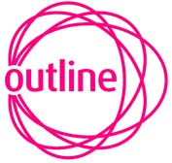

Do you want to slash your weekly food bill?

Would you like to know how to feed your friends and family delicious food without breaking the bank?

Top TV chefs Allegra McEvedy and Paul Merrett are on the look-out for members of the public to appear in an exciting new BBC Two food series Economy Gastronomy.

In each programme Paul and Allegra will challenge a family, couple or a group of flatmates to spend a week following their culinary rules of Economy Gastronomy, which will allow them to eat exciting food for substantially less than they usually spend. Our chefs will teach them a new way of eating, based on careful planning, strategic shopping, seasonal eating and traditional recipes.

If you think that your household could be up to this challenge and would be interested in appearing on the programme, Outline Productions would love to hear from you.

Email at – Food@outlineproductions.co.uk
or
Call Nick on - 020 7424 7663
or
Text your name to 07906 103923

